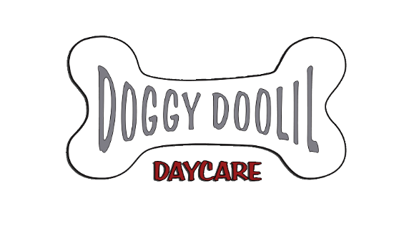
Dogs name: Date:

The answers you provide does not determine whether your dog is accepted or not. They simply give us an understanding of your dog's history. Please answer all questions. You must fill out a separate profile for each dog you wish to enroll in daycare. This form also covers boarding dogs.

Pet Profile
Owner Information:
Name
Mobile Number
Address
City
Postal Code
Email

Emergency Contact:
Name
Mobile Phone
Email

Veterinarian Information:
Name
Phone Number

Dog Information:
Name
Breed
Age / D.O.B?
Spayed/Neutered? Yes No
M / F

Date of your pets’ next booster shot?

How old was your dog when you first obtained him/her?

Is this your first dog?

How long have you had your dog?

Do you understand pack leadership, and are you the leader of your pack?

If adopted or rescued, what knowledge do you have of your dog's history?

Do you have other pets?

How does your dog get along with these pets?

How many elimination walks do you give your dog per day?

Is your dog potty trained?

What are your training styles used to potty train?

Do you still use potty mats?

Do you take your dog to designated Off Leash parks?
If no, please explain.

What is your dog's training history?

How would you respond if your dog did something wrong in the home?

Please list the following if any apply to your dog re: Pre-existing or current medical conditions. Orthopedic problems, i.e., hip dysplasia, arthritis, loose kneecaps?

Allergies environmental –

Allergies to food –

Medications –

Is your dog on a monthly flea preventative? Yes No

Is your dog vaccinated for Bordetella (kennel cough)? Yes No

Is your dog vaccinated for Leptospirosis? Yes No

How does your dog react to strangers or other dogs approaching your home or yard (apartment)?

How does your dog react to strangers or other dogs out in public?

Does your dog fear or dislike any types of people, or types of dogs?
(Please list)

Is your dog frightened by anything like noises, people, specific breed of dogs or objects?

Has your dog ever bitten a person or another dog, or is the dog still mouthy?

Is your dog possessive of another family member or of toys, food, or objects?

Can we give your dog treats while in daycare?

Is your dog sensitive about any parts of his/her body?

Where are your dog's favorite petting spots?

Please list any comments about your dog that you feel will be helpful to us.
i.e., digging, problem house training, whining, barking etc...

How did you hear about our daycare?
Telling us how you found us tells us how much you know about us and what I might need to share with you. Also, if a friend refers you to us, we want to know so they can receive their reward for sharing us with friends. Our referral program offers a free day of daycare.

Google Maps
Website
Friend
Facebook page
Local Pet Store
Dog Park

We must have a copy of your dog's vaccination records before
starting daycare or boarding with us.

